Module 1: Cloud Concepts Overview

Section 1: Introduction to cloud

computing

After completing this module, you should be able to:

• Define different types of cloud computing

• Describe six advantages of cloud computing

• Recognize the main AWS service categories and core services

• Review the AWS Cloud Adoption Framework (AWS CAF)

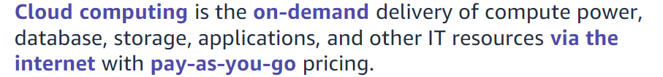

Cloud computing enables you to stop thinking of your infrastructure as hardware, and instead think of (and use) it as software.

With a hardware solution, you must ask if there is enough resource capacity or sufficient storage to meet your needs, and you provision capacity by guessing theoretical maximum peaks. If you don’t meet your projected maximum peak, then you pay for expensive resources that stay idle. If you exceed your projected maximum peak, then you don’t have sufficient capacity to meet your needs. And if your needs change, then you must spend the time, effort, and money required to implement a new solution.

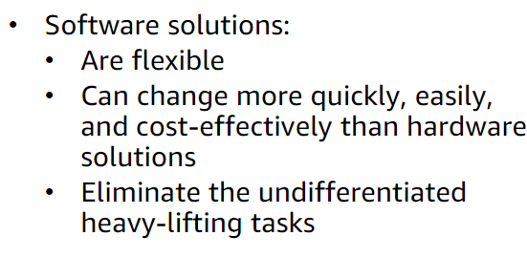

Cloud computing helps developers and IT departments avoid undifferentiated work like procurement, maintenance, and capacity planning, thus enabling them to focus on what matters most.

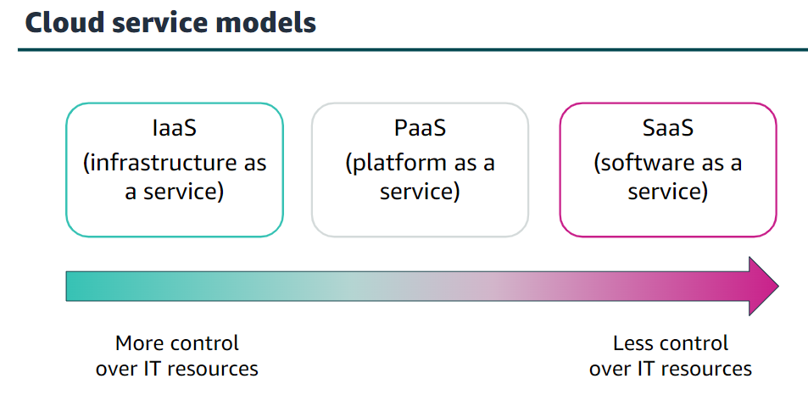

* Infrastructure as a service (IaaS): Services in this category are the basic building blocks for cloud IT and typically provide you with access to networking features, computers (virtual or on dedicated hardware), and data storage space.
* Platform as a service (PaaS): Services in this category reduce the need for you to manage the underlying infrastructure (usually hardware and operating systems) and enable you to focus on the deployment and management of your applications.
* Software as a service (SaaS): Services in this category provide you with a completed product that the service provider runs and manages. In most cases, software as a service refers to end-user applications. With a SaaS offering, you do not have to think about how the service is maintained or how the underlying infrastructure is managed   
    
  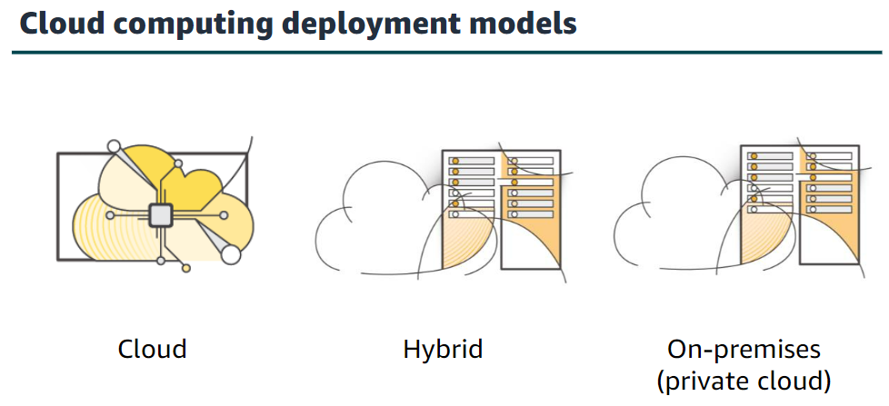
* Cloud: A cloud-based application is fully deployed in the cloud, and all parts of the application run in the cloud. Applications in the cloud have either been created in the cloud or have been migrated from an existing infrastructure to take advantage of the benefits of cloud computing
* Hybrid: The most common method of hybrid deployment is between the cloud and existing on-premises infrastructure. This model enables an organization to extend and grow their infrastructure into the cloud while connecting cloud resources to internal systems.
* On-premises: Deploying resources on-premises, using virtualization and resource management tools, is sometimes called private cloud. While on-premises deployment does not provide many of the benefits of cloud computing, it is sometimes sought for its ability to provide dedicated resources.

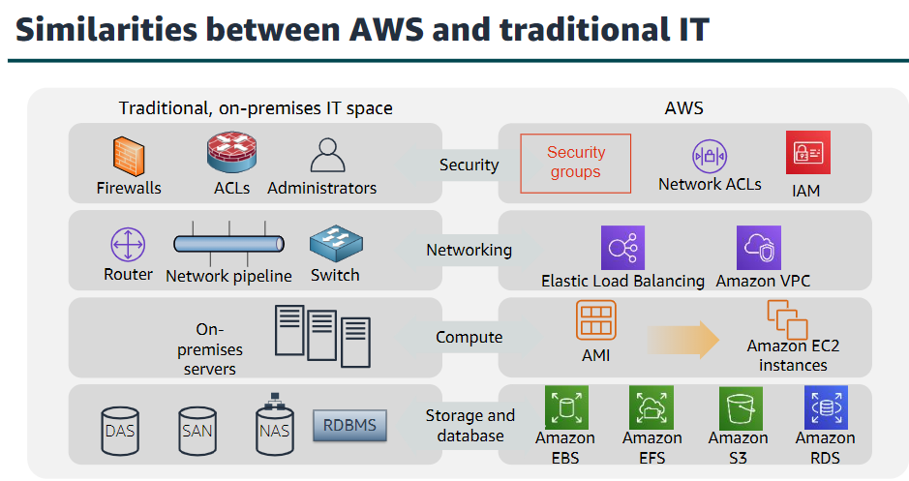

There are many similarities between AWS and the traditional, on-premises IT space:

* AWS security groups, network access control lists (network ACLs), and AWS Identity and Access Management (IAM) are similar to firewalls, access control lists (ACLs), and administrators.
* Elastic Load Balancing and Amazon Virtual Private Cloud (Amazon VPC) are similar to routers, network pipelines, and switches.
* Amazon Machine Images (AMIs) and Amazon Elastic Compute Cloud (Amazon EC2) instances are similar to on-premises servers.
* Amazon Elastic Block Store (Amazon EBS), Amazon Elastic File System (Amazon EFS), Amazon Simple Storage Service (Amazon S3), and Amazon Relational Database Service (Amazon RDS) are similar to direct attached storage (DAS), storage area networks (SAN), network attached storage (NAS), and a relational database management service (RDBMS).

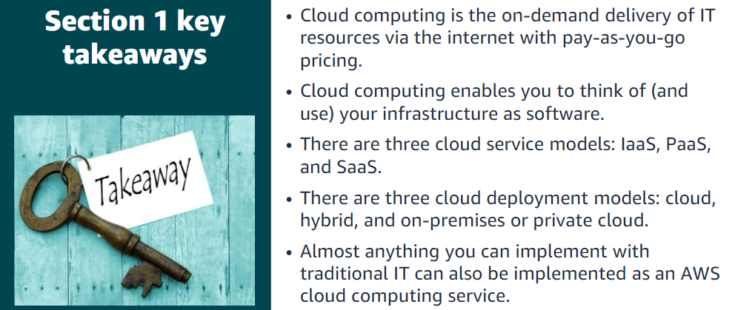

Section 2: Advantages of cloud

computing

Advantage #1—Trade capital expense for variable expense: Capital expenses (capex) are funds that a company uses to acquire, upgrade, and maintain physical assets such as property, industrial buildings, or equipment.

By contrast, a variable expense is an expense that the person who bears the cost can easily alter or avoid. Instead of investing heavily in data centers and servers before you know how you will use them, you can pay only when you consume resources and pay only for the amount you consume. Thus, you save money on technology.

Advantage #2—Benefit from massive economies of scale: By using cloud computing, you can achieve a lower variable cost than you can get on your own. Because usage from hundreds of thousands of customers is aggregated in the cloud, providers such as AWS can achieve higher economies of scale, which translates into lower pay-as-you-go prices.

Advantage #3—Stop guessing capacity: Eliminate guessing about your infrastructure capacity needs. When you make a capacity decision before you deploy an application, you often either have expensive idle resources or deal with limited capacity. With cloud computing, these problems go away.

Advantage #4—Increase speed and agility: In a cloud computing environment, new IT resources are only a click away, which means that you reduce the time it takes to make those resources available to your developers from weeks to just minutes.

Advantage #5—Stop spending money on running and maintaining data centres: Focus on projects that differentiate your business instead of focusing on the infrastructure.

Advantage #6—Go global in minutes: You can deploy your application in multiple AWS Regions around the world with just a few clicks. As a result, you can provide a lower latency and better experience for your customers simply and at minimal cost

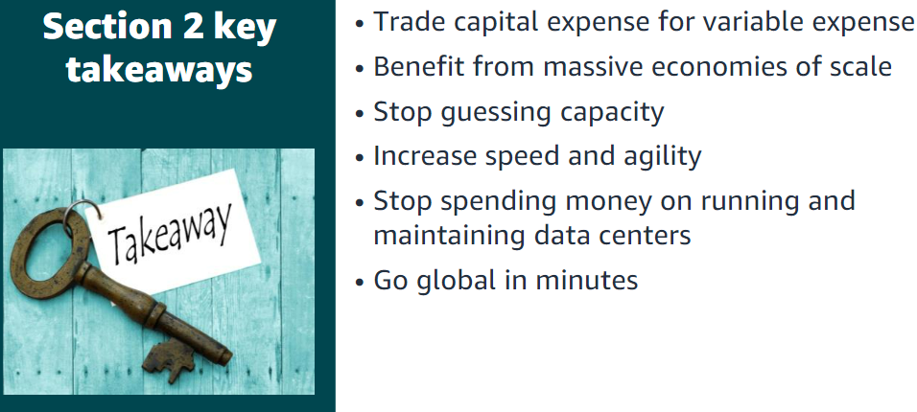

Section 3: Introduction to Amazon

Web Services (AWS)

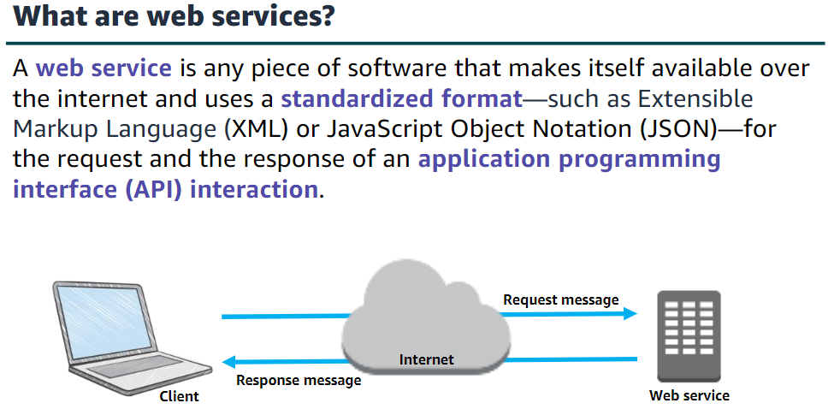

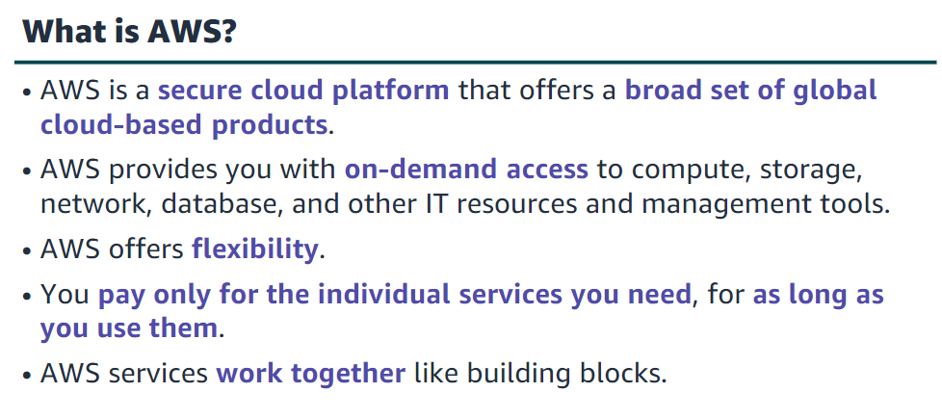

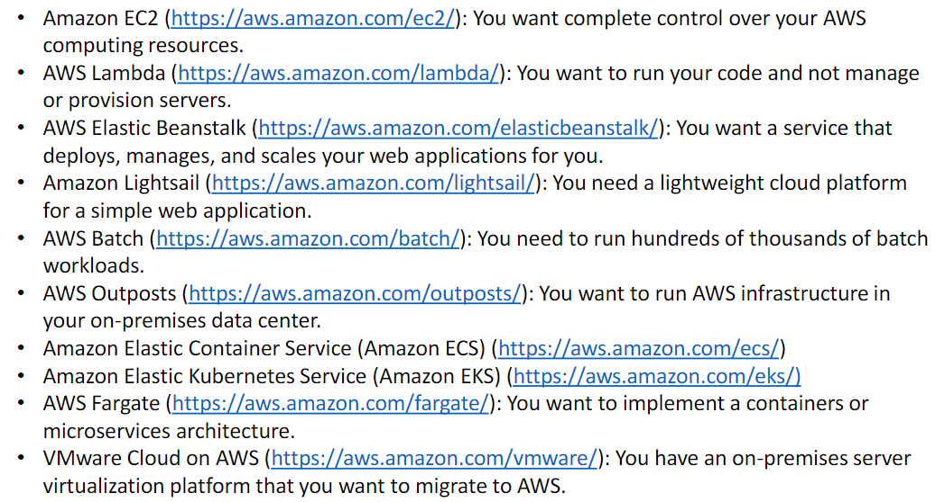

There are three ways to create and manage resources on the AWS Cloud:

**•AWS Management Console**: The console provides a rich graphical interface to a majority of the features offered by AWS.

**•AWS Command Line Interface (AWS CLI):** The AWS CLI provides a suite of utilities that can be launched from a command script in Linux, macOS, or Microsoft Windows.

**•Software development kits (SDKs):** AWS provides packages that enable accessing AWS in a variety of popular programming languages.

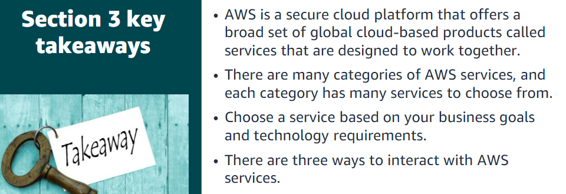

Section 4: Moving to the AWS Cloud –The AWS Cloud Adoption Framework (AWS CAF)

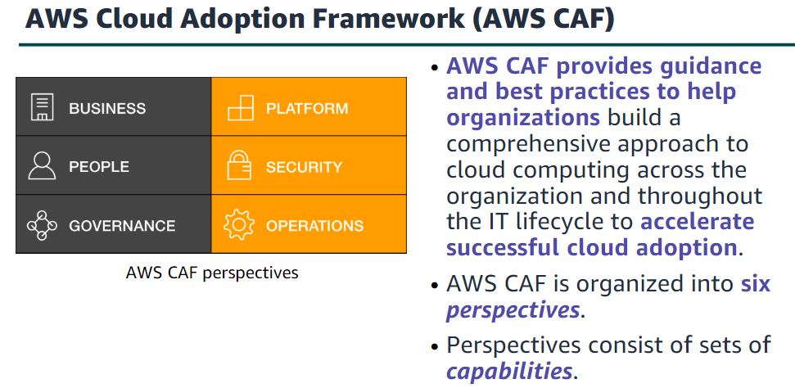

Business V/S Technical

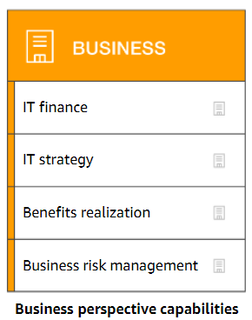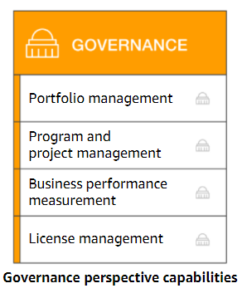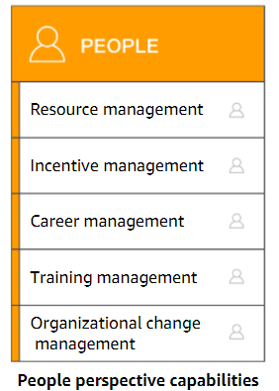

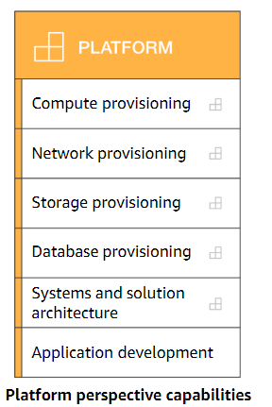

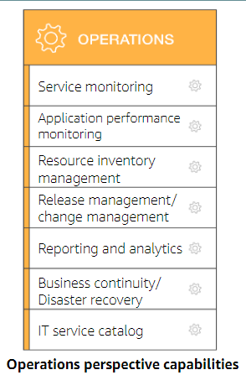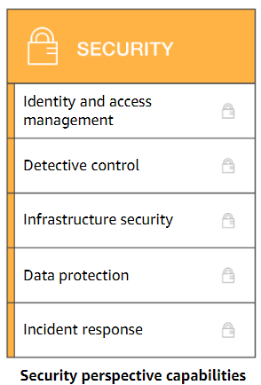

Module 2: Cloud Economics and Billing

Section 1: Fundamentals of pricing

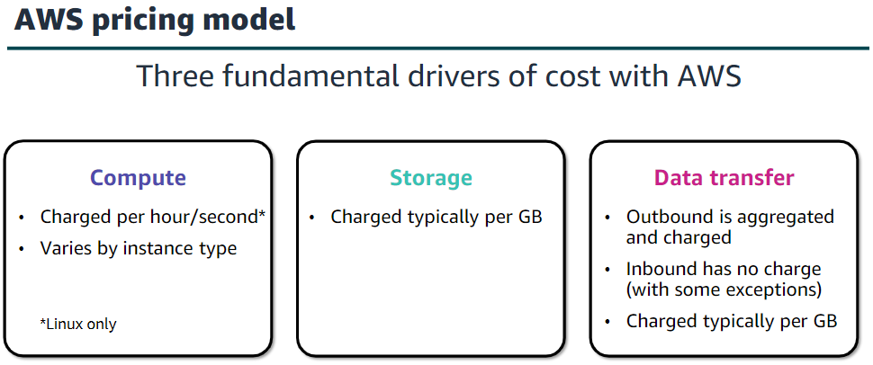

AWS offers a range of cloud computing services. For each service, you pay for exactly the amount of resources that you actually need. This utility-style pricing model includes:

•Pay for what you use

•Pay less when you reserve

•Pay less when you use more

•Pay even less as AWS grows

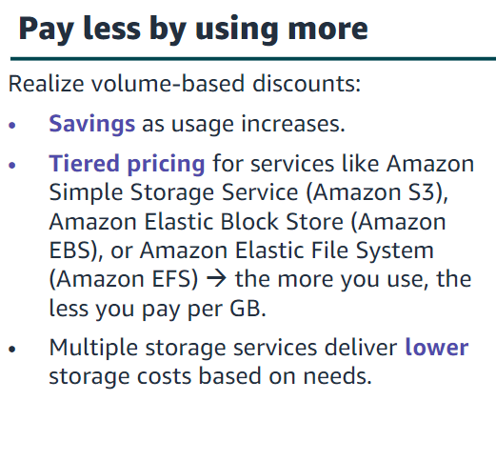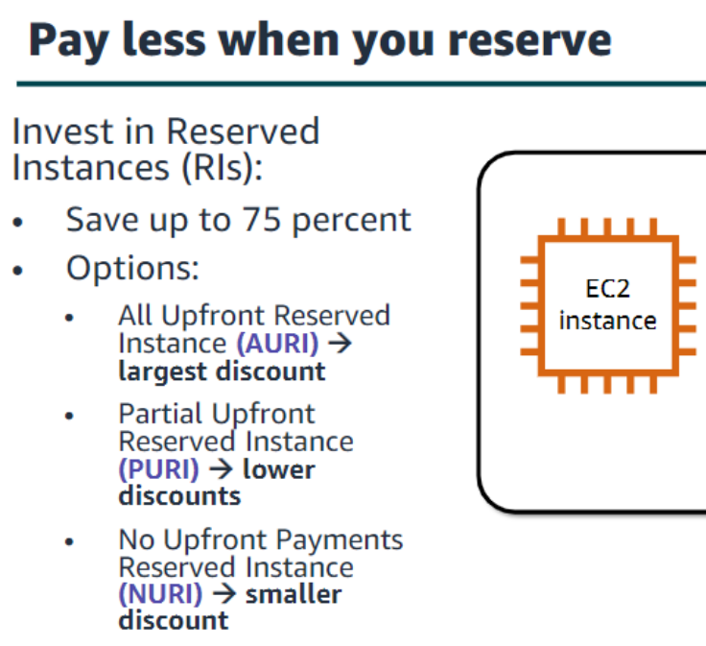

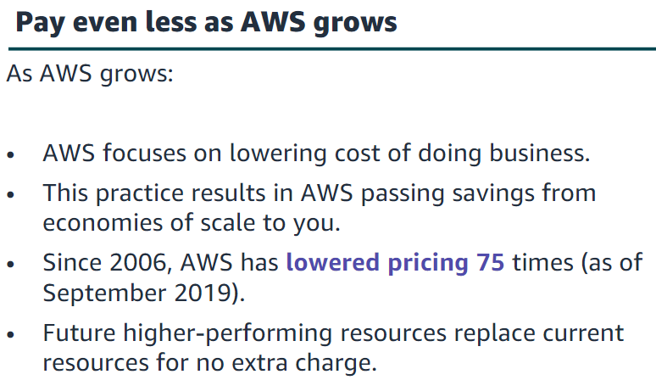

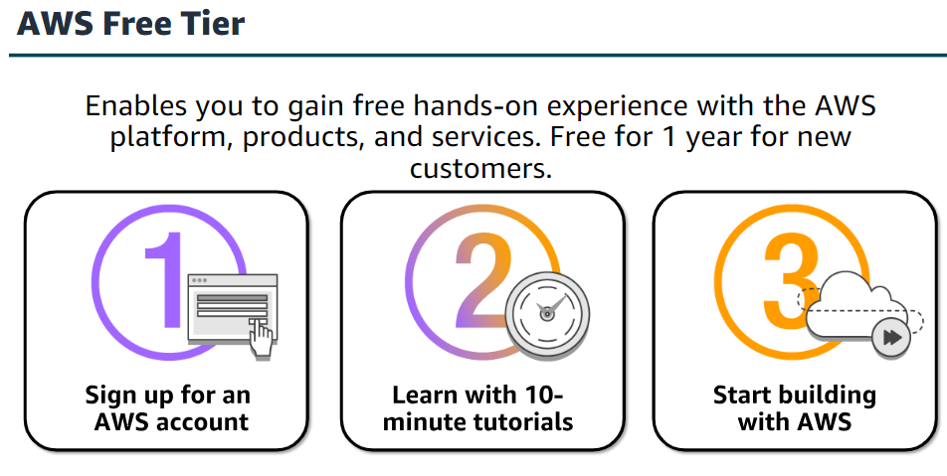

•Amazon Virtual Private Cloud (Amazon VPC) enables you to provision a logically isolated section of the AWS Cloud where you can launch AWS resources in a virtual network that you define.

•AWS Identity and Access Management (IAM) controls your users’ access to AWS services and resources.

•Consolidated Billing is a billing feature in AWS Organizations to consolidate payment for multiple AWS accounts or multiple Amazon Internet Services Private Limited (AISPL) accounts*. Consolidated billing provides:

•One bill for multiple accounts.

•The ability to easily track each account’s charges.

•The opportunity to decrease charges as a result of volume pricing discounts from

combined usage.

•And you can consolidate all of your accounts using Consolidated Billing and get tiered benefits.

•AWS Elastic Beanstalk is an even easier way for you to quickly deploy and manage applications in the AWS Cloud.

• AWS CloudFormation gives developers and systems administrators an easy way to create a collection of related AWS resources and provision them in an orderly and predictable fashion.

•Automatic Scaling automatically adds or removes resources according to conditions you define. The resources you are using increase seamlessly during demand spikes to maintain performance and decrease automatically during demand lulls to minimize costs.

•AWS OpsWorks is an application management service that makes it easy to deploy and operate applications of all shapes and sizes.